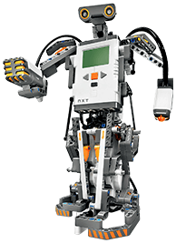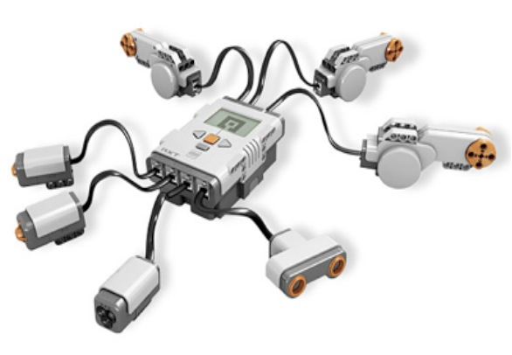

April 2012

**This Certifies that you have Successfully demonstrated the robotic behavior**

**Touch and Release**

Josh and Jose.

J. J. Co.

Congratulations!

**Jessicarae Nuñez**

**Rich Bakala**

Henry and Mark

Robot Masters

April 2012

**This Certifies that you have Successfully demonstrated the robotic behavior**

**Touch and Release**

Congratulations!

**Jessicarae Nuñez**

**Rich Bakala**

Riley and Tristan

April 2012

**This Certifies that you have Successfully demonstrated the robotic behavior**

**Touch and Release**

Congratulations!

**Jessicarae Nuñez**

**Rich Bakala**

S n L

Saber and Wallid

April 2012

**This Certifies that you have Successfully demonstrated the robotic behavior**

**Touch and Release**

Congratulations!

**Jessicarae Nuñez**

**Rich Bakala**

Garrett

April 2012

**This Certifies that you have Successfully demonstrated the robotic behavior**

**Touch and Release**

Congratulations!

**Jessicarae Nuñez**

**Rich Bakala**

Zachariah and Samantha

April 2012

**This Certifies that you have Successfully demonstrated the robotic behavior**

**Touch and Release**

Congratulations!

**Jessicarae Nuñez**

**Rich Bakala**

The Other Guys

Nathan and Jacob

April 2012

**This Certifies that you have Successfully demonstrated the robotic behavior**

**Touch and Release**

Congratulations!

**Jessicarae Nuñez**

**Rich Bakala**

Zach and Xavier

Where’s the Beef

April 2012

**This Certifies that you have Successfully demonstrated the robotic behavior**

**Touch and Release**

Congratulations!

**Jessicarae Nuñez**

**Rich Bakala**

April 2012

**This Certifies that you have Successfully demonstrated the robotic behavior**

**Touch and Release**

Josh and Jose.

J. J. Co.

Congratulations!

**Jessicarae Nuñez**

**Rich Bakala**

Congratulations!

Emma and Brittney

Superman’s

April 2012

**This Certifies that you have Successfully demonstrated the robotic behavior**

**Touch and Release**

**Jessicarae Nuñez**

**Rich Bakala**